## **Exercise 1: Control Structures**

## Scenario 2: Promote Customers to VIP Based on Balance

### **Aim:-**

### Set IsVIP = 'TRUE' for all customers whose balance exceeds $10,000.

### **Approach**

* Add an IsVIP column in the Customers table (if not present).
* Use a **Cursor FOR loop** to select eligible customers.
* Update IsVIP to 'TRUE'.
* Commit the changes and show a message.

### **PL/SQL Code**

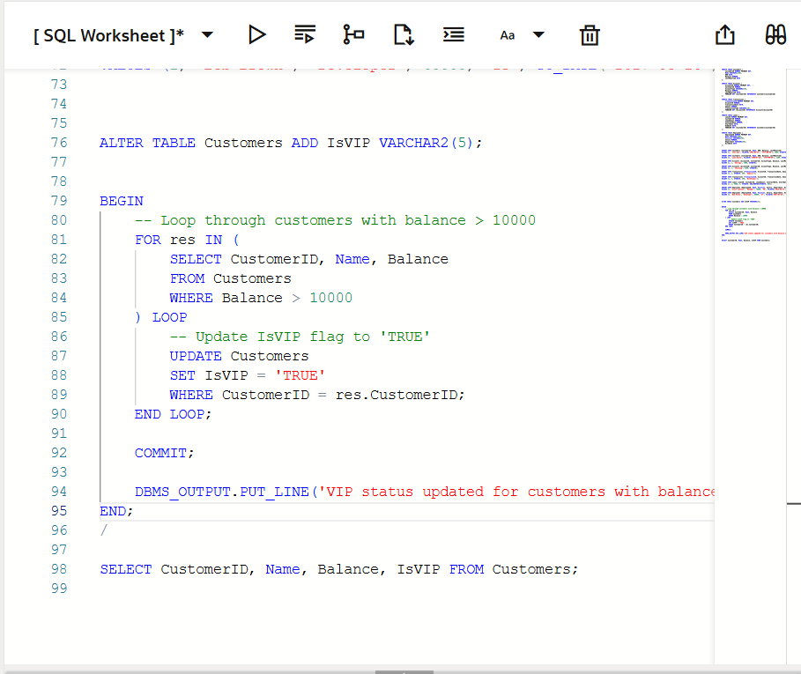

### **Result**

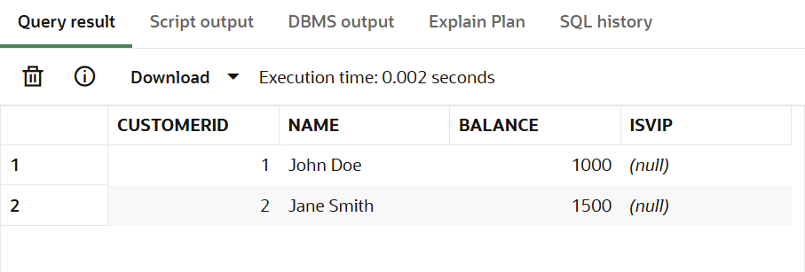

Since the Balance of each is not more than $10000 so null is indicated there